SYSTEM ANALYSIS DOCUMENTATION (SAD)
UMHackathon 2026
umhackathon@um.edu.my

Team: The Four Musketeer
_______________________________________________
- Introduction:

This project introduces an MediFlow AI is an AI-powered pre-consultation system designed to address the critical challenges of long patient waiting times, inefficient history-taking, and clinician workload in primary healthcare clinics.

  - Purpose:

The document outlines the technical scope and design-related decisions behind the MediFlow AI development.

So, the key element of system that has been covered are as followed:

- Architecture:
The system is a client-side web application with a lightweight architecture. The frontend is built using HTML, Tailwind CSS, and JavaScript and runs entirely in the browser. The backend is a Node.js server that acts as a proxy between the frontend and the AI model. The Ilmu GLM 5.1 API is called from the Node.js backend. All patient reports, doctor decisions, and conversation history are stored in browser local storage – no external database is required. The system is designed to be deployable in resource-constrained clinics with minimal infrastructure.
- Data Flows:
Patient symptom data flows from the chat interface, through the Node.js backend, to the Ilmu GLM 5.1 API for processing. The AI returns structured clinical insights, which are displayed as a report card and saved to local storage. The doctor dashboard reads pending reports from local storage, and approval/rejection decisions are written back. The patient then reads the decision banner from local storage on their next page load. File attachments are converted to base64 and included in the API request; no separate file storage is used. All data persists locally in the browser without cloud synchronization.
- Model Process:
The model shows the end-to-end workflow of the core features: patient symptom collection (adaptive questioning, one per turn, up to 20 data points), emergency detection (keyword override with high-severity classification), AI report generation (structured JSON with chief complaint, risk level, possible causes, treatment plan), doctor approval (review, approve/reject with notes), and patient feedback (approval/rejection banner displayed). The process is linear: patient → AI interview → report → doctor review → decision → patient notification.

- Role of Reference:
This document serves as a reference for developers, testers, and future contributors to understand the overall high-level architecture, data flow, and design decisions of the MediFlow AI project. It defines the technical scope, testing strategies, risk mitigation approaches, and acceptance criteria. It is intended to guide development, ensure consistency across the team, and provide a foundation for future enhancements such as backend database integration, user authentication, and EMR connectivity.
  - Background:

Public primary healthcare clinics face significant challenges in patient waiting time and consultation efficiency. Studies have shown that patients wait an average of 41 minutes from registration to seeing a doctor, while the actual consultation lasts only 18 minutes— much of which is spent on repetitive history-taking rather than diagnosis or treatment planning. Staff shortages, high patient volumes, and manual pre-consultation processes further exacerbate the issue, leading to patient frustration, delayed care, and clinician burnout.

- Previous Version:
The current "version" of post-discharge care relies on manual tracking by the patient or their caregivers. Patients use physical checklists for medication and follow-up visits, which often leads to missed appointments or undetected health risks due to a lack of real-time communication with doctors.
- Changes in Major Architectural Components
- Centralized AI Core: Transitioning from paper-based logs to a centralized GLM-powered backend that can parse and understand natural language updates from patients.
- Doctor-in-the-loop Interface: Introducing a digital "Approval Module" where AI suggestions must be reviewed by a medical professional, replacing the unreliable method of patients self-diagnosing or waiting for the next physical appointment.
- Real-time Risk Alerting: Implementation of an automated "Workflow Engine" that replaces manual triage with instant notifications based on analyzed risk levels (Low, Mid, High).
- New capabilities that are only introduced in this
- Adaptive Patient Interviewing: AI asks one follow-up question per turn, systematically collecting 20 clinical data points
- PDF-Ready Report Generation: Structured clinical summary ready for printing or digital sharing
- Risk ClassificationAI classifies patient risk as Low, Medium, or High based on collected data

  - Target Stakeholder
Stakeholders | Roles | Expectations
Patient | Inputs daily recovery data (medication, physical symptoms, and rehab progress) and receives real-time guidance. | A simple, user-friendly interface to track recovery and receive immediate alerts if something is wrong.
Doctor | Inputs initial clinical instructions, reviews AI-generated health reports, and approves recovery plan modifications. | High-accuracy risk detection and a structured "Human-in-the-loop" workflow to monitor patients remotely.
Nurse | Receives automated triage notifications for high-risk patients and provides urgent clinical intervention. | Clear, prioritized alerts for emergency cases and an updated digital record of the patient's daily status.
Development Team | Builds the core GLM-integrated platform, the Decision Engine, and the Workflow Engine. | Clear API usage contracts, modular system architecture, and well-documented data flow between the AI and database.
QA Team | Validates system behavior for all risk levels (Low, Mid, High) and ensures high-risk alerts are delivered reliably. | Defined testing scope for AI response parsing and coverage of medical "edge cases".

- System Architecture & Design

  - High Level Architecture

    - Overview:
Type | Details
System | Web-based application (responsive web, no native mobile app)
Architecture | Client-Server with lightweight backend + External AI API

MediFlow AI is a web-based application with a client-server architecture. The system consists of two types of clients: the Patient Web Interface (chat.html) for conducting pre-consultation interviews, and the Doctor Web Dashboard (doctor.html) for reviewing and approving AI-generated reports. Both clients communicate with a Node.js Backend API, which then interfaces with the external Ilmu GLM 5.1 API for AI processing. All patient reports, doctor decisions, and conversation history are stored in browser local storage, eliminating the need for a dedicated database in the current prototype.

    - LLM as Service Layer

The Ilmu GLM 5.1 API is integrated as a dedicated AI service layer, with prompts constructed by the Node.js backend combining system prompt, conversation history, and user message (2,500-3,500 tokens per request). The frontend parses responses as JSON — valid reports are saved to localStorage as report cards, while plain text is displayed as follow-up questions. Input limits: 4,000 character text messages (rejected if exceeded), 30-turn limit, and 5MB file attachments (larger files cause performance issues).

    - Dependency Diagram
- The Node.js backend constructs prompts by combining: system prompt (medical assistant role instructions) + conversation history (previous turns) + current user message. The backend then sends a POST request to Ilmu GLM 5.1 API with this combined prompt in JSON format.
- System prompt (~1,500 tokens), conversation history (200-300 tokens per turn), and current user message (50-100 tokens). Total context window is approximately 2,500 to 3,500 tokens per request.
- Node.js backend receives raw text response from GLM API and forwards it to frontend. Frontend attempts to parse as JSON. If valid JSON with completed report → display report card and save to localStorage. If plain text or invalid JSON → display as chat bubble (follow-up question) and continue conversation.
- Token limits are enforced at the frontend level. Text messages exceeding ~4,000 characters are rejected with an error message before reaching the API. No chunking or truncation is performed. Conversation is hard-limited to 30 turns. File attachments up to 5MB are accepted with no chunking.
- Patient Web App → Node.js Backend: POST /api/chat (send patient message, receive AI response) Node.js Backend → Ilmu GLM 5.1 API: POST https://api.ilmu.ai/v1/chat (send prompt, receive AI response) Patient Web App → localStorage: localStorage.setItem() and getItem() (save/read reports) Doctor Web App → localStorage: localStorage.getItem() and setItem() (read pending reports, save decisions)
- Patient Web App sends HTTP request to Node.js Backend. Backend calls external Ilmu GLM 5.1 API and waits for response. Backend returns response to frontend. Frontend reads from and writes to browser localStorage (acts as database). Doctor Web App directly reads/writes the same localStorage. No external database is used currently.
- The current prototype is monolithic (single Node.js backend + static frontend). For production deployment, the system can be split into: CDN for static frontend files, containerized Node.js backend on ECS/Kubernetes with auto-scaling, API Gateway for rate limiting and authentication, PostgreSQL on RDS to replace localStorage, and the Ilmu GLM 5.1 API remains as external service.

    - Sequence Diagram
This flow demonstrates how the system handles a "High Risk" emergency scenario.

Step 1: Patient Entry
- Patient opens application and selects "I'm a Patient" from role screen
- System directs patient to chat interface
Step 2: Symptom Description
- Patient types symptoms in plain language (e.g., "I have a headache for 3 days")
- Frontend sends message to Node.js backend via POST /api/chat
Step 3: AI Processing
- Backend constructs prompt with system prompt + conversation history + user message
- Backend sends to Ilmu GLM 5.1 API
- AI extracts symptom, location, duration, severity
- AI identifies missing information
Step 4: Follow-Up Questions
- AI returns one follow-up question (e.g., "Pain scale 1-10?")
- Question displays as chat bubble
- Patient answers
- Progress bar updates
- "Collected So Far" side panel refreshes with extracted data
- Repeat until all 20 data points collected
Step 5: Emergency Detection (if triggered)
- Patient mentions emergency keyword (e.g., "chest pain")
- System immediately overrides normal flow
- Severity set to "high"
- Report generates without remaining questions
Step 6: Report Generation
- After all data collected, AI returns structured JSON report
- Frontend parses JSON
- Report card displays with severity badge (Low/Medium/High)
- Queue number and consultation room assigned
- Report saved to local storage
- Flag set for doctor review
Step 7: Doctor Review
- Doctor opens dashboard and selects "I'm a Doctor"
- Dashboard reads pending reports from local storage
- Doctor selects report to review
- Clinical summary, attachments, and AI reasoning displayed
- Doctor clicks Approve or Reject (adds optional notes)
- Decision saved to local storage with timestamp
Step 8: Patient Notification
- Patient opens or refreshes chat page
- System reads doctor's decision from local storage
- If approved: Green banner displays "Report approved" with recommended action
- If rejected: Red banner displays "Report rejected. Please restart consultation"
Step 9: Flow Completion
- Patient proceeds to doctor with approved report
- Doctor uses report during consultation
- Or patient restarts if report rejected

  - Technological Stack
    - Frontend
- Tailwind CSS for styling (utility-first, responsive)
- Vanilla JavaScript for logic (no frameworks, lightweight)
    - Backend
- FastAPI (Python): Chosen for its high performance and native support for asynchronous calls to the GLM API, which is essential for low-latency triage.
    - Database
- Browser localStorage (key-value storage)
- Stores: pending reports, doctor decisions, consultation history

    - Cloud/Deployment
- Frontend: Static files served from local file system or any static hosting
- Backend: Deployed on any cloud VM or local server (e.g., AWS EC2, Google Compute Engine, DigitalOcean)

  - Key Data Flows
    - Here, do show the how data are moving through the system and how its structure and stored
      - Data Flow Diagram (DFD)
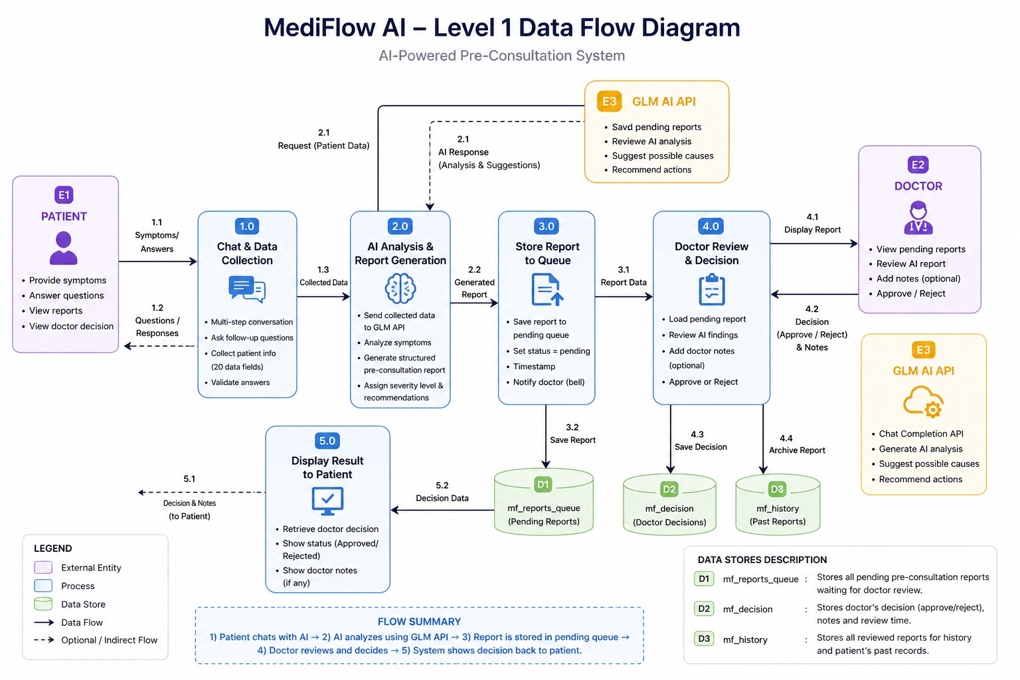

    - Normalized Database Schema
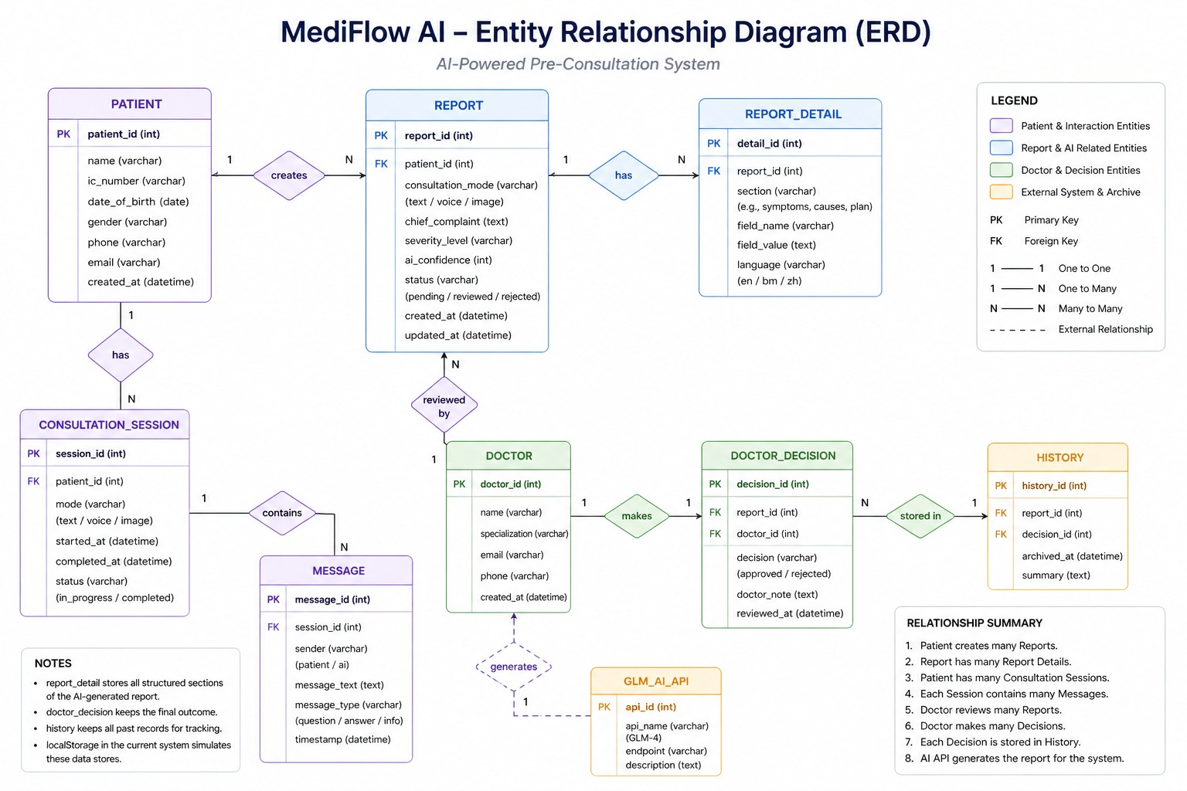

- Functional Requirements & Scope
This section highlights the core boundaries of the projects. That enables them to focus on a high-impact MVP to showcase the technical feasibility of the project.

  - Minimum Viable Product:
    - Do list down 3-5 core features that the team is going to build and do a demo by the end of the UMHackathon 2026. [e.g. in Table]
# | Features | Description
1 | AI-Powered Pre-Consultation Chat | Patient describes symptoms in plain language; AI asks one follow-up question per turn and systematically collects up to 20 clinical data points (symptoms, duration, severity, medical history, medications, allergies, lifestyle).
2 | Emergency Detection & Risk Classification | System detects emergency keywords (e.g., "chest pain," "cannot breathe," "stroke") and immediately overrides normal flow; classifies patient risk as Low, Medium, or High and displays severity badge on report card.
3 | AI Report Generation & PDF Output | After collecting all data, AI generates structured JSON clinical report including chief complaint, symptom timeline, medical history, risk level, AI reasoning, suggested action, possible causes, and treatment plan; report card displays queue number and consultation room.
4 | Doctor-in-the-Loop Approval Dashboard | Doctor views pending AI-generated reports, reviews clinical summaries and attachments, and approves or rejects each report with optional notes; decision saved to localStorage and displayed to patient as approval/rejection banner.
5 | Multi-Language & File Attachment Support | AI auto-detects and responds in English, Bahasa Malaysia, or Chinese; patients can attach images (rashes)

  - Non-Functional Requirements (NFRs)
Here, highlights the system qualities that are not features but are crucial for reliability and improve the system. [e.g. table in below]
Quality (e.g.) | Requirements (e.g.) | Implementation (e.g)
Scalability | The system must handle concurrent consultations during peak clinic hours (e.g., 8am-10am and 5pm-7pm) with at least 20 simultaneous patient sessions without significant degradation. | Node.js backend can be containerized and deployed with auto-scaling (e.g., Kubernetes HPA); frontend static files served via CDN; stateless backend allows horizontal scaling.
Reliability | The system must have 99% uptime during clinic operating hours. API failures must not crash the application. Patient data must not be lost on network errors. | Graceful error handling with retry logic; localStorage persists data locally; system displays user-friendly error messages instead of crashing; conversation history preserved on failure.
Maintainability | Frontend and backend are separated into distinct modules. The AI prompt logic is isolated from UI rendering code. System prompt can be updated without changing frontend code. | Modular JavaScript architecture; system prompt stored as constant variable; backend handles prompt construction independently; changes to prompts or API endpoints require only backend updates.
Token Latency | AI API calls must return a response within 3 seconds under normal load (p95). Typing indicator must appear within 500ms of sending a message. | Timeout set at 5 seconds for API calls; loading state (typing animation) displays immediately; conversation history limited to 30 turns to keep token count manageable.
Cost Efficiency | Average token cost per patient session must not exceed $0.01 USD. Session costs must remain predictable regardless of conversation length. | Single question per turn (not batching) keeps each API call short; system prompt loaded once per session; conversation capped at 30 turns; no chunking or unnecessary retries.

  - Out of Scope / Future Enhancements
- Real-time Video Consultation: Integrated in-app video calling between the patient and doctor for remote examinations.
- Wearable Device Synchronization: Automated data syncing with IoT hardware (e.g., smartwatches) to track heart rate and oxygen levels in real-time.
- Multi-Language Voice Support: The ability for patients to provide verbal updates in multiple regional dialects beyond the initial project scope.
- Monitor, Evaluation, Assumptions & Dependencies

  - Technical Evaluation:
    - Grayscale Rollout & A/B Testing: The team will deploy new features using a gradual rollout approach to minimize risk and ensure system stability. For example, when introducing a new AI prompt version or an updated risk classification model, the feature will initially be released to 5% of clinic sessions (e.g., one clinic or 5% of patient traffic). System performance, API response times, hallucination rates, and doctor approval rates will be monitored for 24-48 hours. If no critical issues or anomalies are detected, the rollout will be gradually increased to 25%, then 50%, and finally 100% of all clinic sessions.
    - Emergency Rollback (ER) & Golden Release: If anomalies are detected during deployment or normal operation, the Emergency Rollback (ER) process is triggered immediately. Anomalies include API error rate exceeding 10%, average response time exceeding 5 seconds for 5 consecutive minutes, hallucination rate exceeding 10%, or critical bugs (P0/P1) reported by doctors. When ER is triggered, the system automatically reverts to the last known stable version (Golden Release) within 5 minutes.

    - Priority Matrix:

Priority | Level | Trigger Condition | Action Taken
P0 | Critical | AI fails to detect emergency keyword (e.g., "chest pain" classified as low risk) | Immediate emergency rollback to Golden Release; manual review of all affected reports; notify clinic supervisor
P1 | High | API error rate exceeds 10% over 5 consecutive minutes | Automatic emergency rollback to Golden Release; notify on-call engineer; redirect traffic to stable version
P2 | High | AI hallucination rate exceeds 10% (reports rejected by doctors due to fake symptoms) | Manual rollback trigger; pause grayscale rollout; doctor review escalation
P3 | Medium | API response time exceeds 5 seconds average over 5 minutes | Alert development team; scale backend resources; investigate latency cause; no rollback unless escalates

  - Monitoring:

Metric | Target | Monitoring Method | Alert Threshold | Trigger Action
API Response Time | < 3 seconds | Backend request logging | > 5 seconds for 5 minutes | Send alert to development team; investigate latency
API Error Rate | < 5% | Backend error logging | > 10% over 5 minutes | Automatic emergency rollback; notify on-call engineer
Emergency Detection Accuracy | 100% | Manual test suite + keyword logging | Missed emergency keyword | Immediate P0 rollback; manual report review
Report Hallucination Rate | < 5% | Doctor rejection rate tracking | > 10% of reports rejected by doctors | Manual rollback trigger; pause feature rollout

  - Assumptions: State key operational & environmental conditions that you assumed to be valid while development of system and deployment.
- Patients can read and type symptoms in English, Bahasa Malaysia, or Chinese
- Clinic computers run modern browsers (Chrome, Firefox, Edge, or Safari 2020 or newer)
- Clinic has stable internet connection during operating hours
- At least one doctor is available to approve or reject reports during clinic hours
- Patients complete their consultation in one session without closing the browser
- Multiple patients may use the same shared clinic computer
- Patients will not use browser incognito or private mode
- Patients will attach files under 5MB in size
- Ilmu GLM 5.1 API maintains 99% uptime during clinic hours

  - External Dependencies: Do list all the external tools that are applied to your system to function. [e.g. below]

Tools | Purpose | Risks
Z Ai GLM API | Core LLM reasoning engine – handles prompt inference, multi-step reasoning, medical entity extraction, risk classification, and structured JSON report generation | High – API downtime or rate limiting would cause core product to fail; patients cannot complete consultations

- Project Management & Team Contributions
  - Project Timeline:
Days(s) | Phase | Activities
Day 1-2 | Project Planning & Requirements | Define scope, core features, user stories, and technical requirements; set up development environment
Day 3-4 | Frontend Development | Build chat interface, role selection screen, progress bar, side panel, and report card using HTML, Tailwind CSS, and JavaScript
Day 5-6 | Backend & AI Integration | Set up Node.js server, integrate Ilmu GLM 5.1 API, implement prompt construction, conversation history management, and response parsing
Day 7 | Doctor Dashboard Development | Build doctor interface for viewing pending reports, approving/rejecting with notes, and localStorage integration
Day 8 | Testing & Bug Fixing | Execute unit tests, integration tests, adversarial tests, and hallucination tests; fix critical bugs
Day 9 | Documentation & PRD Finalization | Complete product requirement document, technical specifications, and user guides
Day 10 | Demo Preparation & Final Polish | Record demo video, prepare presentation slides, finalize code repository

  - Team Members Role:
Lim Jian Jun | Frontend Lead | Develop chat interface, role selection screen, progress bar, side panel, report card, and doctor dashboard using HTML, Tailwind CSS, and JavaScript
Chan Hui Ern | Backend Lead | Set up Node.js server, integrate Ilmu GLM 5.1 API, implement prompt construction, conversation history management, and response parsing
- Lim Jian Jun  - Chan Hui Ern | AI Integration & Testing Lead | Configure system prompts, implement Chain-of-Thought reasoning, conduct hallucination tests, adversarial tests, and emergency detection validation
- Ng Shi Hui  - Muhammad Iqbaal | Documentation & PRD Owner | Write product requirement document, technical specifications, user stories, test cases, and prepare demo presentation
All Members | Integration & Deployment | Collaborate on end-to-end testing, bug fixing, and demo preparation

  - Recommendations:
Category | Recommendation | Justification
Scalability | Replace browser localStorage with cloud database (e.g., PostgreSQL on AWS RDS) | localStorage limited to 5-10MB per browser; cloud database enables report sharing across devices, multi-clinic deployment, and centralized analytics
Performance | Add streaming responses (character-by-character) instead of waiting for full response | Improves perceived performance; patients see AI typing in real-time instead of waiting 2-3 seconds for complete response
Reliability | Add retry logic with exponential backoff for API failures | Automatically retries failed API calls up to 3 times with increasing delays (1s, 2s, 4s) before showing error message

